EXPERIMENT NO-13: MINMAX ALGORITHM FOR GAMING
Aim
To implement the Minimax algorithm for gaming using Prolog. The algorithm helps a computer player choose the best possible move by considering the possible moves of the opponent.
Algorithm
- Represent the Tic-Tac-Toe board as a list of 9 positions.
- Generate all possible moves for the current player.
- Check whether the current board is a winning, losing, or draw state.
- Assign a score:
  - 1 → AI wins
  - -1 → Opponent wins
  - 0 → Draw
- For the AI's turn, select the move with the maximum score.
- For the opponent's turn, select the move with the minimum score.
- Continue recursively until a terminal state is reached.
- Select the move with the best score as the AI's move.
Python Code
# Minimax Algorithm for Tic-Tac-Toe

board = [' ' for _ in range(9)]

def display_board():
print()
print(board[0], '|', board[1], '|', board[2])
print('--+---+--')
print(board[3], '|', board[4], '|', board[5])
print('--+---+--')
print(board[6], '|', board[7], '|', board[8])
print()

def winner(player):
combinations = [
(0, 1, 2),
(3, 4, 5),
(6, 7, 8),
(0, 3, 6),
(1, 4, 7),
(2, 5, 8),
(0, 4, 8),
(2, 4, 6)
]
for a, b, c in combinations:
if board[a] == board[b] == board[c] == player:
return True
return False
def minimax(is_maximizing):
if winner('O'):
return 1
if winner('X'):
return -1
if ' ' not in board:
return 0
if is_maximizing:
best_score = -1000

for i in range(9):
if board[i] == ' ':
board[i] = 'O'
score = minimax(False)
board[i] = ' '
best_score = max(best_score, score)

return best_score

else:
best_score = 1000

for i in range(9):
if board[i] == ' ':
board[i] = 'X'
score = minimax(True)
board[i] = ' '
best_score = min(best_score, score)

return best_score

def best_move():
best_score = -1000
move = 0

for i in range(9):
if board[i] == ' ':
board[i] = 'O'
score = minimax(False)
board[i] = ' '

if score > best_score:
best_score = score
move = i

return move

# Main game
print("TIC-TAC-TOE USING MINIMAX")
print("You are X, Computer is O")

while True:
display_board()

# Human move
position = int(input("Enter your position (1-9): ")) - 1

if position < 0 or position > 8 or board[position] != ' ':
print("Invalid move. Try again.")
continue

board[position] = 'X'

if winner('X'):
display_board()
print("You win!")
break

if ' ' not in board:
display_board()
print("It's a draw!")
break

# Computer move
computer_move = best_move()
board[computer_move] = 'O'

print("Computer chose position:", computer_move + 1)

if winner('O'):
display_board()
print("Computer wins!")
break

if ' ' not in board:
display_board()
print("It's a draw!")
break

OUTPUT
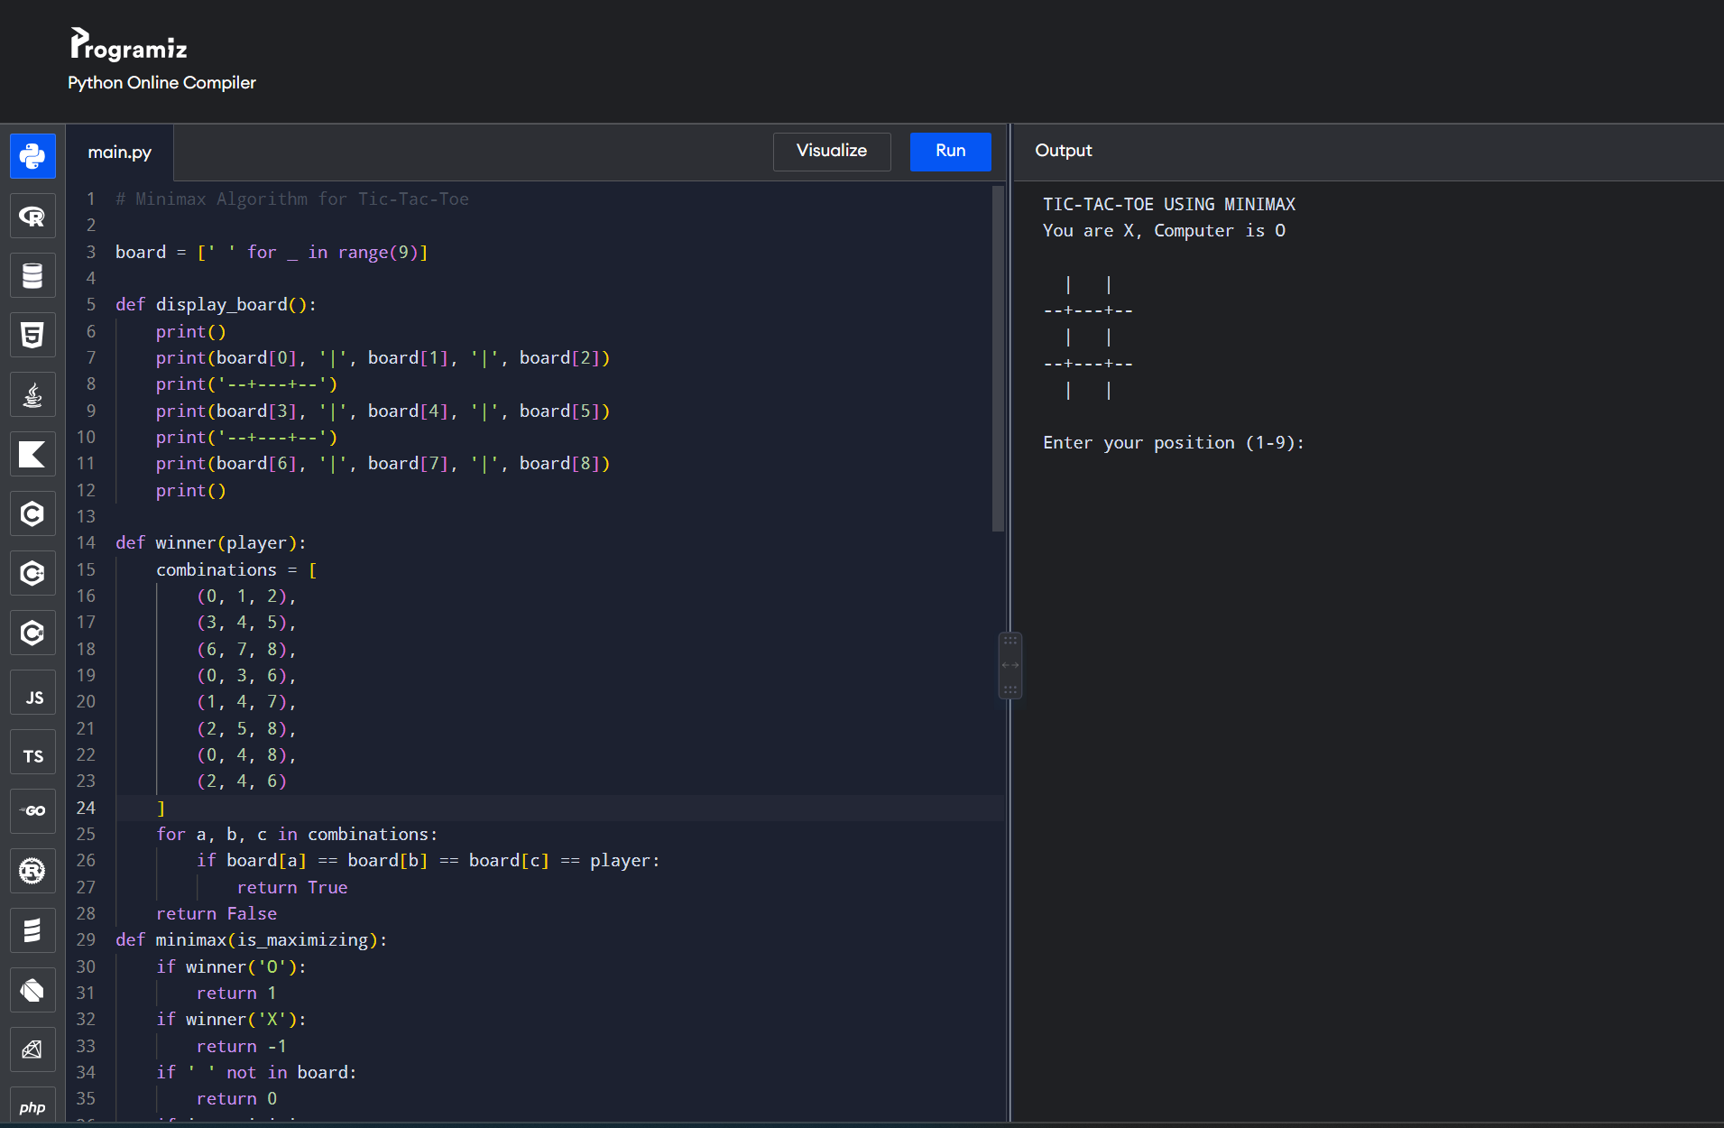
Result
Thus, the Minimax algorithm was successfully implemented in Prolog for a gaming problem. The program evaluates possible game states and selects the optimal move for the computer player.

